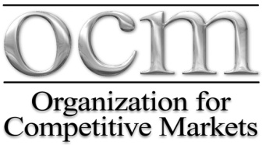

REGISTRATION FORM
18th Annual Food and Agriculture Conference
“Preserving Independent Family Agriculture through Competitive Markets”

Friday, August 19, 2016
Doubletree Hilton Omaha Downtown,1616 Dodge Street, Omaha, NE
Call in for Reservations – OCM Block (Rate $99.00+) Elaina 402-636-4906 (M-F)
Or make your reservation on our website: competitivemarkets.com - Deadline 8/5/16

NAME (S): ____________________________________________________________________________

____________________________________________________________________________

COMPANY: ___________________________________________________________________________

ADDRESS: ____________________________________________________________________________

PHONE: _________________________________________

CITY/STATE/ZIP: _____________________________________________________________________

EMAIL: ___________________________________________________________________

REGISTRATION

REGISTRATION includes all day Conference on Friday, August 19 beginning at 8:00 AM

______ Number attending OCM Conference @ $50.00 = $______

_______Number attending 2016 LUNCH @ $30.00 = $_______
(Friday, August 19, 12:00 Noon)

_______Number attending 2016 BANQUET @ $45.00 = $_______
(Friday, August 19 – 6:00 PM)

TOTAL Registration & Meals = $___________

________Attending Membership Meeting, Saturday August 20 – 8:00 AM

Make check payable to OCM,
P. O. Box 6486, Lincoln, NE 68506

